Programming ATtiny with Arduino Nano

initial steps in Arduino:

File - Preferences:

insert into Additional Boards Manager URLs: <https://raw.githubusercontent.com/damellis/attiny/ide-1.6.x-boards-manager/package_damellis_attiny_index.json> (more lines are separated with comma)

and click OK

Tools - Board: - Boards Manager - find „attiny“ - Install - Close

Connect Nano in USB

Arduino:

- Tools - Board - Arduino AVR Boards - Arduino Nano

- Tools - Processor - ATmega328P (old bootloader) or ATmega328P

- Tools - Port - select com port

- Tools - Programmer - AVRISP mkII

- File - Examples - ArduinoISP

- Sketch - Upload

continue: Wire Arduino Nano with Arduino ATtiny:

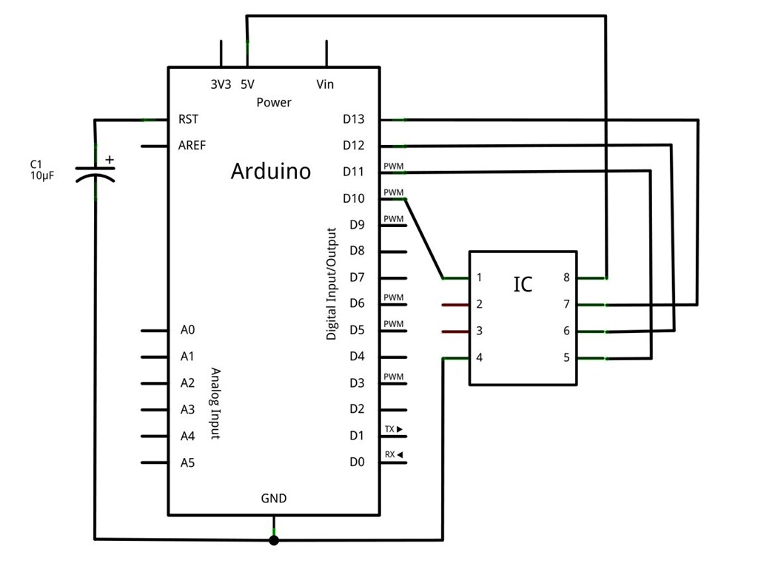

Arduino:

- Tools - Board - ATtiny microcontrollers - select proper attiny

- Tools - Processor - select proper attiny

- Tools - Port - select com port (the one with Nano)

- Tools - Programmer - Arduino as ISP

- File - Examples - Blinking (edit sketch with proper LED pin (0))

- Sketch - Upload

(I am not sure if there was or was not burned bootloader in the brand new attiny IC, if so do it)

after programming remove the reset pin and capacitor from attiny